Voltech Solar Controller SCP030 & SCP050
Firmware update V2.2
New Firmware has become available for the Voltech SCP030 and SCP050, offering improved safety and performance. With the new firmware, a new app has also been created to easily install the V2.2 firmware.
The original Eco Solar app still works as usual and can still update to V2.2 if the user prefers.
Instruction how to install V2.2 via Eco Solar OTA app
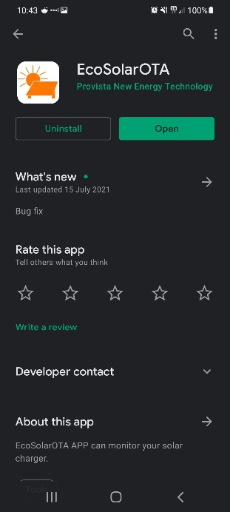
- Download the Eco Solar OTA app from apple store / Google play store
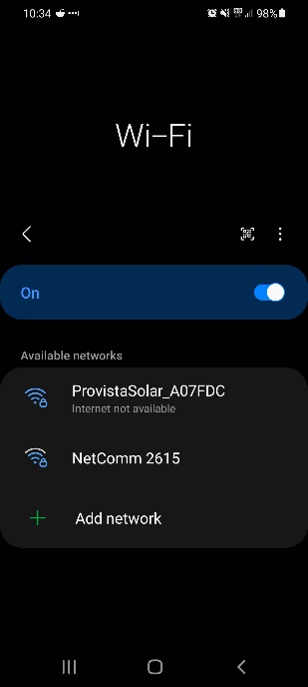
Google play - https://play.google.com/store/apps/details?id=com.provista.solarota
Apple - https://apps.apple.com/au/app/eco-solar-ota/id1575699481

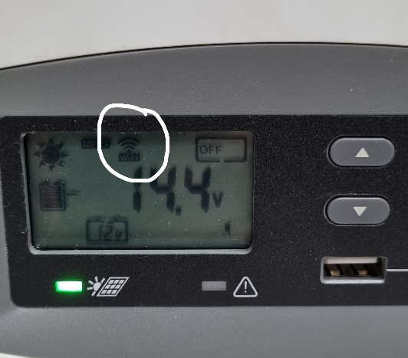

2a) The solar controller must be powered on showing home screen with Wi-fi setting turned on, the Wi-Fi symbol will be flashing if turned on, please refer to owner’s manual.

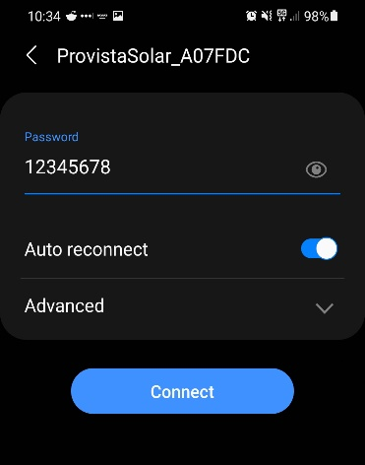
2b) Connect your device to the Voltech Solar controller. WIFI and Bluetooth must be turned on for connection. Enter Password as shown (12345678). If connection to solar controller has previously been established, please simply connect your device to the solar controller as normal.

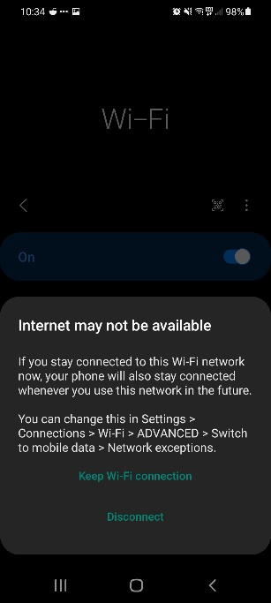
- A message may appear detailing no internet connection available, please select
“keep Wi-fi connection”

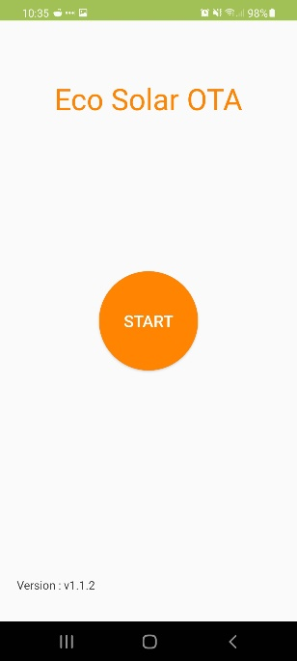
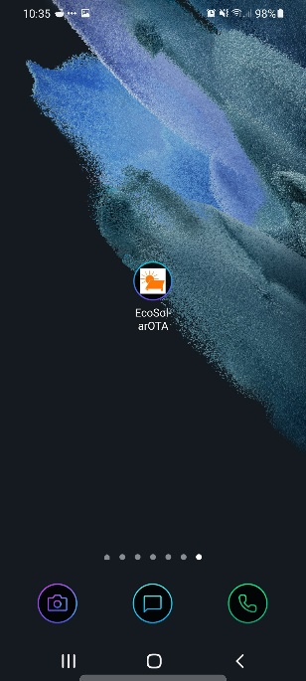

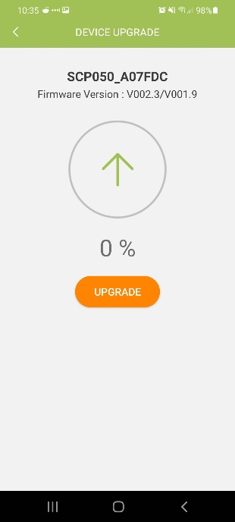
- Launch the new Eco Solar OTA app that was installed in step
1.

- Press “start”, new page will be shown, please confirm the
following is correct before proceeding:
- Correct unit is selected IE SCP050
- Correct mac address is selected IE A07FDC (this can be
confirmed by checking the mac address located on the top
right side of unit)
Please take note of current version IE V00.23/V001.9
failure to confirm above may result in incorrect unit updating.

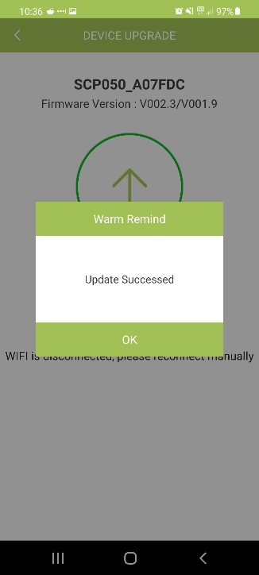
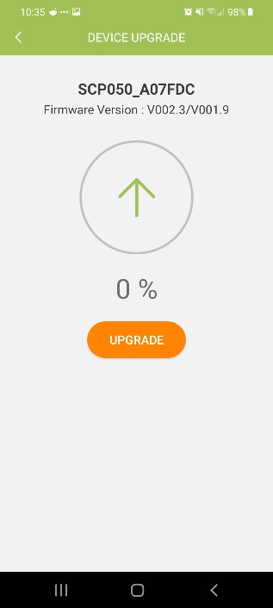
- Press update. Device will show the progress of the update. Please DO NOT close app
or change to a different application, doing so may interrupt update resulting in
damage to controller.

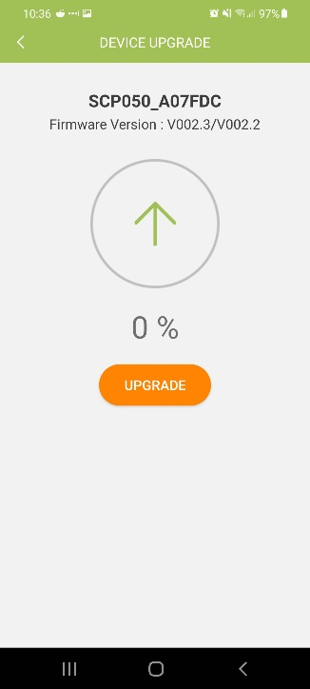
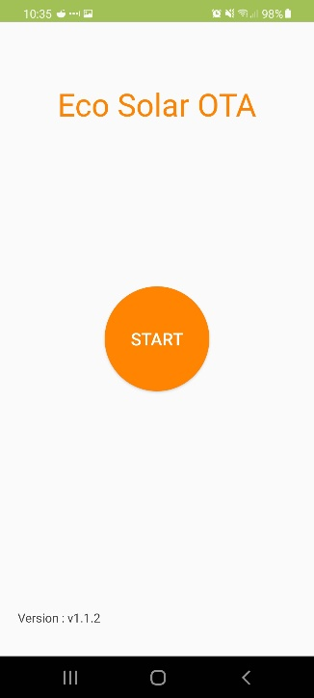
- Once complete, message box will appear informing of the successful update. Select
“ok” and the app will take you back to the home screen in step 3. The solar
controller will restart and Wi-fi connection will be lost. Once the solar controller
power on again, Wi-fi connection will automatically reconnect.

- Once connection has been re-established, press “start”,
here you can see the new firmware has been installed to the
solar controller IE V002.3/V002.2
From here, the solar controller firmware has been updated
successfully.

